**Hiring Process Analytics**

**Project Description :**

The project was designed to conduct comprehensive data analytics on the hiring process within a company, with the primary objective of gaining insights into various aspects such as gender distribution, salary analysis, departmental composition, and position tiers. By analyzing these factors, the project aimed to provide valuable insights into hiring patterns and organizational dynamics.

**Approach**

To accomplish the project objectives, a systematic approach was followed. A dataset containing relevant information on hires, including gender, salary, department, and position, was obtained. Microsoft Excel 2022 was selected as the primary tool for data analysis due to its versatility and robust capabilities in handling tabular data. Specific techniques such as pivot tables, charts, and formulas were employed to analyse the dataset and extract meaningful insights.

**Tech-Stack Used**

Software: Microsoft Excel 2022

Purpose: Excel was chosen for its extensive data analysis functionalities, including pivot tables, charts, and statistical functions. It facilitated in-depth exploration and visualization of the hiring data, enabling a thorough understanding of the underlying trends and patterns.

**Insights**

Through the data analytics process, several key insights were uncovered:

* Analysis of gender distribution provided insight.
* Salary analysis revealed.
* Examination of departmental composition highlighted.
* Analysis of position tiers uncovered.

Meaningful trends and patterns were observed in the data, shedding light on.

1. **Hiring Analysis:**

The hiring process involves bringing new individuals into the organization for various roles.

Your Task: Determine the gender distribution of hires. How many males and females have been hired by the company? Result:

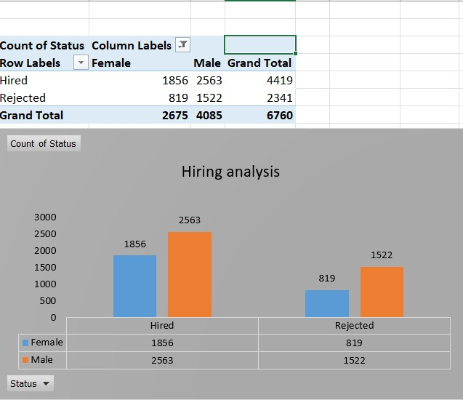

1. **Salary Analysis:**

The average salary is calculated by adding up the salaries of a group of employees and then dividing the total by the number of employees.

Your Task: What is the average salary offered by this company? Use Excel functions to calculate this.

Result:

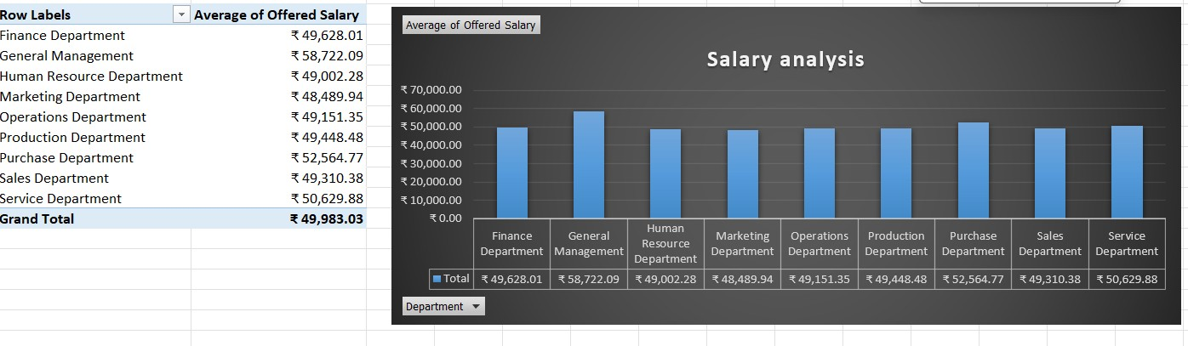

1. **Salary Distribution:**

Class intervals represent ranges of values, in this case, salary ranges. The class interval is the difference between the upper and lower limits of a class.

Your Task: Create class intervals for the salaries in the company. This will help you understand the salary distribution.

Result:

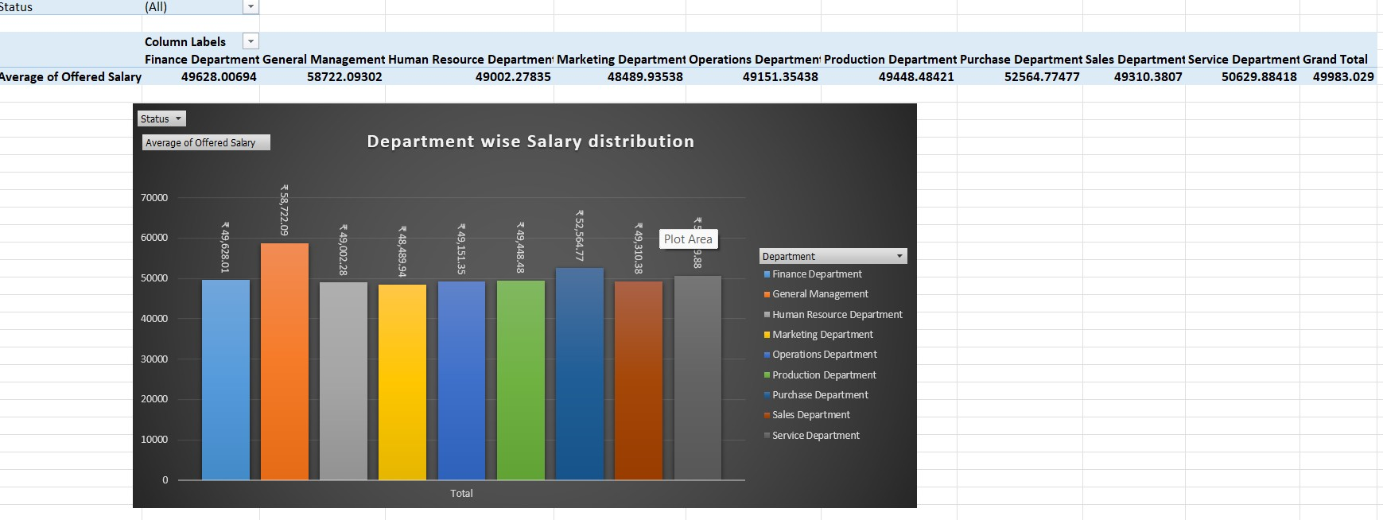

1. **Departmental Analysis:**

Visualizing data through charts and plots is a crucial part of data analysis.

Your Task: Use a pie chart, bar graph, or any other suitable visualization to show the proportion of people working in different departments. **E. Position Tier Analysis**:

Different positions within a company often have different tiers or levels.

Your Task: Use a chart or graph to represent the different position tiers within the company. This will help you understand the distribution of positions across different tiers. **Result for Departmental Analysis and Position Tier Analysis:**

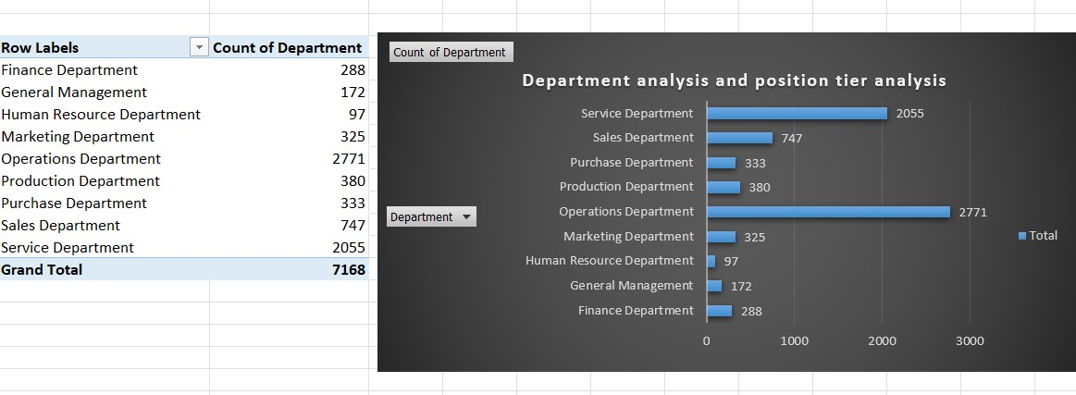

This report summarizes the data analytics tasks performed on the dataset. The provided results offer insights into various aspects of the company, including hiring patterns, salary distribution, departmental composition, and position tiers. Further analysis and interpretation can be conducted based on these findings to inform decision-making processes within the organization.

**Result:**

The project yielded significant insights into the hiring process analytics, contributing to a deeper understanding of organizational dynamics. By analyzing hiring patterns, salary distribution, and departmental composition, actionable insights were obtained to optimize recruitment strategies and drive organizational growth.

**Drive Link**

The final report has been saved as a PDF file and uploaded to Google Drive. You can access the report through the following link**: Click to open Excel Sheet.**

This report provides a comprehensive overview of the data analytics project on the hiring process, detailing the objectives, approach, insights gained, and results achieved. The findings serve as a valuable resource for informed decision-making and strategic planning within the organization.